|  |
| --- |
| **Rapport STEM** |

Naam: ……………………………………………………………………………………………..

Activiteit(en): ………………………………………………………………………………….

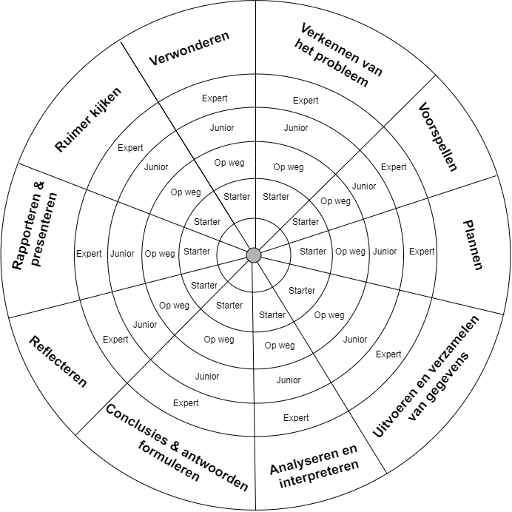

Hier blink je in uit:

………………………………………………………………………………………………………………………………………………………………………………………………………………………………………………………………………………………………………………………………………………………………………………………………………………………………………………………………………………………

Hierin moet je nog groeien:

………………………………………………………………………………………………………………………………………………………………………………………………………………………………………………………………………………………………………………………………………………………………………………………………………………………………………………………………………………………